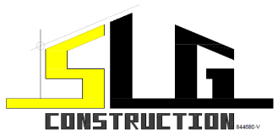 |  |  |  |  | Material Request Form
 |  |  |  |  | Document No.: |  |  | SLG/PRO-CONS/FRM/12/01 |  |  |  |  |  |  | Revision No.: |  |  | 00
 |  |  |  |  | Effective Date: |  |  | 09/02/2024 |  |  |  |  |  |  | Page: |  |  | 1 of 1
Project:
Reference Number:
Below order only for: |  |  |  |  |  | ☐ For Preliminaries Work |  |  |  |  |  | ☐ For Main Building Contract Work
No. | Material |  |  |  |  |  |  |  |  |  | Qty / Unit |  |  | Target Delivery Date |  |  | Remark
Requested by: |  |  |  |  |  |  | Approved by: |  |  |  |  |  | Proceed by: (Procurement Dept.)
Signature: |  |  |  |  |  |  | Signature: |  |  |  |  |  | Signature:
Name: |  |  |  |  |  |  | Name: |  |  |  |  |  | Name:
Position: |  |  |  |  |  |  | Position: |  |  |  |  |  | Position:
Date: |  |  |  |  |  |  | Date: |  |  |  |  |  | Date:
**Please attach additional document(s) for further clarification, if necessary

